Massachusetts Governor’s Office
Attn: The Hon. Charlie Baker
24 Beacon Street
State House
Room 265
Boston, MA 02133

By email: (gov.press@state.ma.us)

Re: An Act Investing in the Future of Our Health

March 25, 2022,

Dear Governor Baker,

Northeast Pharmacy Service Corporation (NPSC) is a pharmacy service administrative organization (PSAO) that provides services to independent community pharmacies in New England with group purchasing opportunities, third party consultation, advocacy, regulatory affairs along with education and training on new business development.

On behalf of NPSC and its participating pharmacies, we would like to thank you for filing “An Act Investing in the Future of Our Health.” As a leading voice for Massachusetts independent pharmacy, we both applaud the Administration’s effort to help bolster Massachusetts’ health care system and offer our full support for this proposed legislation.

There are a few suggested points that we would like to offer which will help make this legislation stronger in relation to pharmacy benefit managers.

- On Page 117 section 32 (a): “A carrier, or a pharmacy benefits manager under contract with a carrier, shall use a single maximum allowable cost list to establish the maximum amount to be paid by a health plan to a pharmacy provider for a generic drug.” or a brand-name drug that has at least one generic alternative available.
- There are no Maximum Allowable Cost (MAC) lists for brand name drugs. MAC lists are only for generic medications.
- On Page 118 line 2488 (ii) “provide a process for a pharmacy (plan) to readily obtain the maximum allowable payment available to that pharmacy under a maximum allowable cost list;”

- We have seen and advocated for an overseeing state department such as either the Department of Insurance or Board of Pharmacy to be designated as a neutral source for grievances. PBMs will argue that this is beyond the state’s regulatory authority since a private contract exists between a PBM and a pharmacy. However; these terms are often one sided and non-negotiable and the way that the pharmacy industry is currently constructed, many pharmacies are forced to sign these contracts through third parties that are heavily restricted by the plans and PBMs from sharing these contracts with the pharmacies for whom they sign on behalf of. Even more troubling is the fact that any contract dispute or reimbursement grievance must go through the same PBM who gave the pharmacy a below cost reimbursement. Having some state oversight is necessary to keep all parties on a level playing field which ensures further transparency.
- NPSC also believes that states need to do a better job of policing both payers and PBMs to make sure they are adhering to reimbursement based on the National Average Drug Acquisition Cost (NADAC) list. In this bill’s case we feel that MAC should never be lower than NADAC for multi-source generic products.

We appreciate you allowing us to pass along our viewpoints and we stand by to readily serve as a resource to you.

Sincerely,

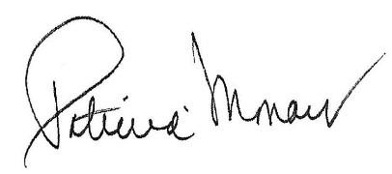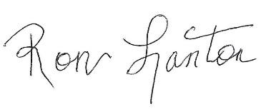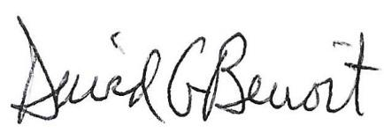
Patricia Monaco Ron Lanton III, Esq. David G. Benoit, MHP, RPh.
President/CEO Corporate Counsel VP, Patient Care Services
Northeast Pharmacy Northeast Pharmacy Northeast Pharmacy
Service Corporation Service Corporation Service Corporation

