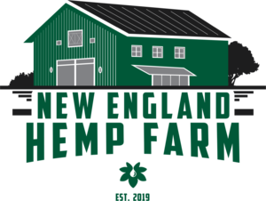
z

Dear NPSC Member,

New England Hemp Farm (NEHF) was chosen by NPSC as the premier CBD partner for their membership . Matt Bannon, COO of NEHF and head of client management and Colin Bannon VP of Sales will be your primary contacts. We also wanted to share with you a quick summary of who NEHF is and what we have to offer:

- NEHF is family owned.
- NEHF is proud to offer quality CBD products you can trust which are all 3rd party independently tested.
- NEHF is currently ranked 4.9 out of 5 stars on Trust Pilot’s review platform. Visit us at www.newenglandhempfarm.com to see what others are saying about us.
- Partnering with NEHF will generate profit margins of 45% to 55% as well as 2.5% of your sales back in commission from NPSC

As we all learn more about the endocannabinoid system, we continue to become aware of new benefits that CBD can bring to a person’s everyday life. Our clients find our products most helpful with inflammation, anxiety, autoimmunity, and sleep cycles. Additionally, we have had customers say they have found some relief for symptoms related to Parkinson’s, MS, Shingles, and Neuropathy.

Please feel free to reach out to me at the contact information below. We have also included our pricing catalogue on the NPSC portal.

Thanks in advance for your consideration and if you have any questions, please feel free to reach out to me.

Stay well,

Matt Bannon
Chief Operating Officer
136 Main Street
Westport Ct 06880
203-451-3852
matt@newenglandhempfarm.com
Instagram: newenglandhempfarmct
Facebook: @newenglandhempfarm

