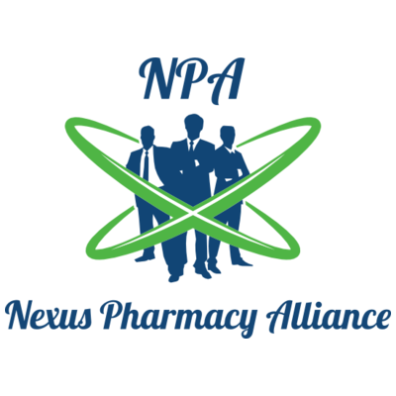
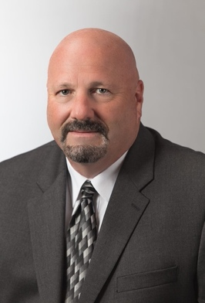

Bill Griffin
Northeast Area
(207)712-6153
BGriffin@NexusPharmacyAlliance.com

Justin Griffin
Northeast Area
(207)730-2687
JGriffin@NexusPharmacyAlliance.com

