Federal Trade Commission
600 Pennsylvania Avenue, NW
Washington, DC 20580

By Electronic Mail (vgraham@ftc.gov)

Re: Pharmacy Collective Bargaining Exemption to Current Antitrust Laws

August 24, 2023

Dear Commissioner Khan,

Northeast Pharmacy Service Corporation (NPSC) is a pharmacy service administrative organization (PSAO) that provides services to independent community pharmacies in New England with group purchasing opportunities, third party consultation, advocacy, regulatory affairs along with education and training on new business development.

On behalf of NPSC and its participating pharmacies, we would like to bring to your attention an issue that has been problematic for many years in the pharmacy community. If the FTC would allow this exemption, we would see stabilization of patient care in the U.S. along with the leveling of a currently uneven marketplace. A marketplace that has been severely out of balance due to the nation’s largest pharmaceutical benefits managers (PBMs).

Since the FTC has remained virtually silent until now on most pharmaceutical antitrust matters, independent community pharmacists have tried unsuccessfully to ban together to amplify their buying power as an answer to unchecked PBMs. Both attempts were through Congressional legislation. It has not been effective.

Starting with the 110th Congress, pharmacy tried to introduce an important exemption to antitrust law that failed to advance due to Congressional pressure exerted by PBMs. H.R. 971 titled the “Community Fairness Act of 2007”. The 111th Congress H.R. 1204 titled the “Community Fairness Act of 2009”, sought to give independent pharmacies the right to band together to collectively negotiate for better terms with managed-care prescription plans.

Pharmacy still believes that the ideals represented in these bills are still viable today! Setting aside antitrust restrictions that prevent community pharmacy owners from negotiating with pharmacy benefit management plans, would help give independent pharmacies the much needed ammunition to survive the onslaught of abusive PBM practices.

The aforementioned bills proposed the following:

- Limit pharmacy negotiating pools to 25% of market share in a Medicare Part D region
- Define an independent pharmacy as one with less than 10% of market share of a prescription drug plan region, as defined under Part D regulations, and less than 1% of market share of the United States;
- Provide a five-year sunset clause from the bill’s passage;
- Mandate a Government Accountability Office study six months before sunset of the law to examine its impact on the marketplace.
Pharmacists believe that a policy like this is needed and would serve as an appropriate response to the current “take it or leave it” contracts. PBMs and payers use their large market influence to subject pharmacies to onerous contract terms coupled with low reimbursement rates, knowing that pharmacies must sign these contracts or risk losing their patients to PBM owned pharmacies. Collective bargaining by community pharmacies would allow pharmacies and indirectly patients, take control of treatment options and set our country on a better and more predictable course of lowering drug costs while improving patient outcomes.

While we understand that we have been discussing legislation and that you need legislation to act, we hope that this letter can serve as an impetus for the FTC to sponsor a bill that encompasses collective bargaining for pharmacies, or that a regulatory scheme can be found that would allow for an antitrust exemption to allow collective bargaining for pharmacies. Doing so would allow pharmacy the chance to compete appropriately without having the pharmacy industry’s terms dictated to them.

Allowing this to go unaddressed will pave the way for the continuation of what we are seeing now; the accelerated closures of small businesses creating marketplace gaps replaced either by a large chain pharmacy or in the alternative the creation of a pharmacy “desert.” You may have seen lately that several CVS and Walgreens locations have been forced to close themselves due to the reckless reimbursement environment that they themselves have created. But we believe that a new era of the FTC is upon us, where the Commission can help restore the marketplace wrongs that have been allowed to go on for too long.

We appreciate you allowing us to pass along our viewpoints and we stand by to readily serve as a resource to you.

Sincerely,

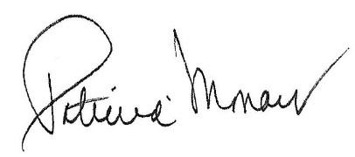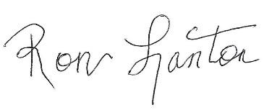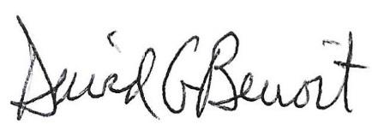
Patricia Monaco Ron Lanton III, Esq. David G. Benoit, MHP, RPh.
President/CEO Corporate Counsel VP, Patient Care Services
Northeast Pharmacy Northeast Pharmacy Northeast Pharmacy
Service Corporation Service Corporation Service Corporation

